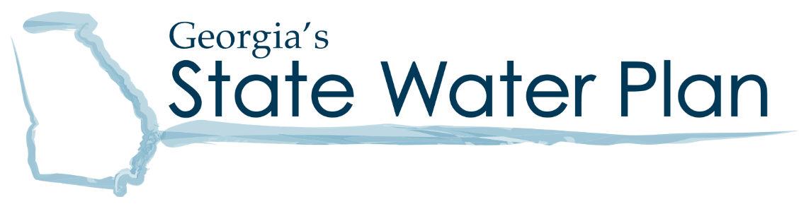

Middle Ocmulgee Regional Water Council Meeting
Agenda – March 14, 2023
9:30 am – 2:30 pm
Amerson WTP – Macon Water Authority
Dr Lee Road, Macon, GA 31211

Objectives:
- Regional Water Planning Updates
- Approve Section 4
- Review / Approve Changes to Sections 3 and 5
- Approve Management Practices

9:30 – 10:00 | Registration / Check-in / Coffee
10:00 – 10:05 | Welcome and Introductions | Chairman Richardson
10:05 – 10:10 | Council Business  - Approve meeting summary from November 2022  - Approve today’s meeting agenda | Chairman Richardson
10:10 – 10:20 | Regional Water Planning Updates and GA EPD Updates  - Schedule | Veronica Craw, EPD
10:20 – 12:00 | Draft Regional Water Plan Update  - Approve Section 4: Forecasts  - Review Section 3 Changes  - Review Section 5 Changes  - Approve Changes + Feedback | Paula Feldman, FNI  Olivia Snyder, FNI
12:00 – 12:45 | LUNCH
12:45 – 2:00 | Management Practices Review / Approval | Paula Feldman, FNI
2:00 – 2:15 | Wrap Up and Next Steps | Chairman Richardson
2:15 – 2:30 | Public Comments/Local Elected Official Comments
2:30 | Adjourn | Chairman Richardson
www.georgiawaterplanning.org

